TASK 1:
#include <iostream>
using namespace std;

int main() {
int n;
cout << "Enter the size of the array: ";
cin >> n;

int data[n];
for (int i = 0; i < n; i++) {
cout << "Enter Element " << i + 1 << ": ";
cin >> data[i];
}

for (int j = 0; j < n - 1; j++) {
for (int i = 0; i < n - 1; i++) {
if (data[i] > data[i + 1]) {
int temp = data[i];
data[i] = data[i + 1];
data[i + 1] = temp;
}
}
}

cout << "Sorted array using Bubble Sort: ";
for (int i = 0; i < n; i++) {
cout << data[i] << " ";
}

return 0;
}

OUTPUT:
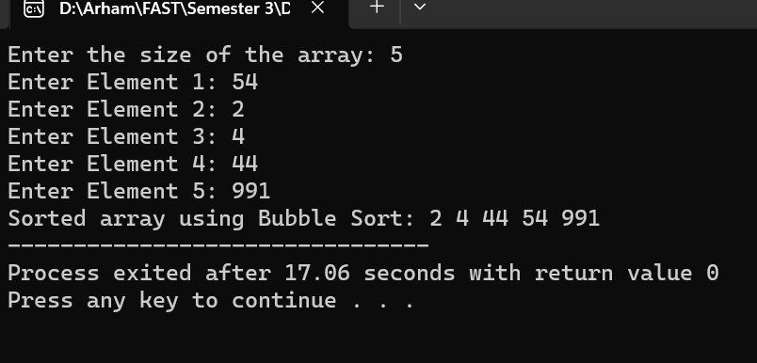

TASK 2:
// 22k-4080

#include <iostream>

using namespace std;

struct date{
int day;
int month;
int year;
};
int main(){
int i,n,j,smallest;

cout<<"Enter size of array: "<<endl;
cin>>n;
date d[n];

for (i=0;i<n;i++){
cout<<"Enter Day "<<i+1<<": ";
cin>>d[i].day;
cout<<"Enter month "<<i+1<<": ";
cin>>d[i].month;
cout<<"Enter Year "<<i+1<<": ";
cin>>d[i].year;
}

for(j=0;j<n-1;j++){
smallest = j;
for(i=j;i<n;i++){
if(d[i].year<d[smallest].year){
smallest=i;
}
}
swap(d[j],d[smallest]);
}

cout << "Sorted Dates:" << endl;
for(i=0;i<n;i++){
cout<<d[i].day<<"/"<<d[i].month<<"/"<<d[i].year<<endl;
}

return 0;
}

OUTPUT:
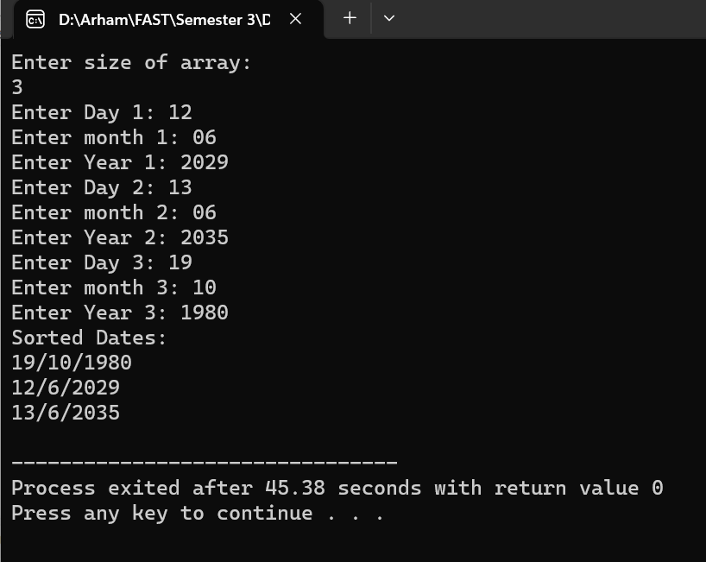

TASK 3:
// 22K-4080

#include <iostream>
#include <string>
using namespace std;

int positionAssigner(string &position){
if(position == "CEO")
return 1;
if(position == "CTO")
return 2;
if(position == "CFO")
return 3;
if(position == "VP")
return 4;
if(position == "MGR")
return 5;
if(position == "EMP")
return 6;

return 7;
}

void customInsertionSort(string positions[], int size){
for (int i = 1; i < size; ++i){
string key = positions[i];
int j = i - 1;

while (j >= 0 && positionAssigner(positions[j]) > positionAssigner(key)) {
positions[j + 1] = positions[j];
j = j - 1;
}
positions[j + 1] = key;
}
}

int main(){

int size;
cout<<"Enter the number of positions: "<<endl;
cin>>size;

string designation[size];

for(int i = 0; i<size;i++){
cin>>designation[i];
}

customInsertionSort(designation,size);

cout << "Sorted job positions:" << endl;
for (int i = 0; i < size; ++i){
cout << designation[i] << endl;
}
}

OUTPUT:
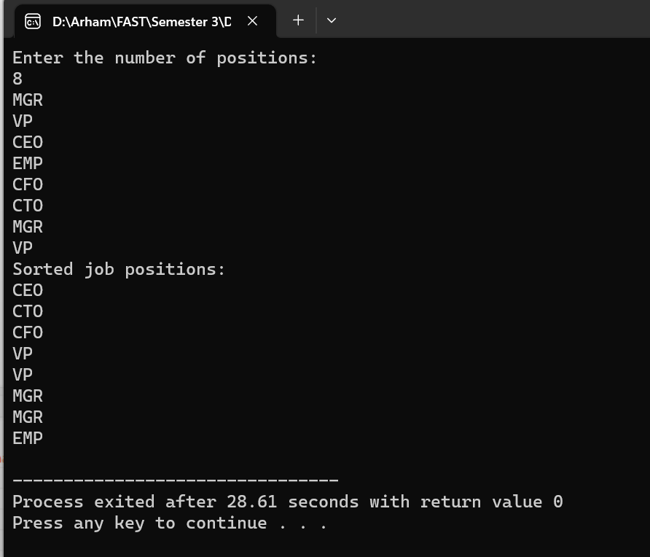

TASK 4: (took some help from stack overflow)
#include <iostream>
#include <string>
using namespace std;

struct Crate {
string id;
string shippingDate;
};

void applyInsertionSort(Crate crates[], int size) {
for (int i = 1; i < size; ++i) {
Crate currentCrate = crates[i];
int j = i - 1;

while (j >= 0 && crates[j].shippingDate > currentCrate.shippingDate) {
crates[j + 1] = crates[j];
j = j - 1;
}
crates[j + 1] = currentCrate;
}
}

int main() {
cout << "Welcome to the Crate Sorting Program!" << endl;

int crateCount;
cout << "Enter the number of crates: ";
cin >> crateCount;

Crate crates[crateCount];
for (int i = 0; i < crateCount; ++i) {
cout << "Enter ID for Crate " << i + 1 << ": ";
cin >> crates[i].id;
cout << "Enter shipping date (YYYY-MM-DD) for Crate " << i + 1 << ": ";
cin >> crates[i].shippingDate;
}

applyInsertionSort(crates, crateCount);

cout << "\nOptimized crate order for shipping:\n";
for (int i = 0; i < crateCount; ++i) {
cout << "Crate " << crates[i].id << " (Shipping Date: " << crates[i].shippingDate << ")\n";
}

cout << "Crates are now arranged for shipping!" << endl;

return 0;
}

OUTPUT:

